The first time beginning to use GIT

1. In local project. - do initialization

**git init**

qians-mbp:learn qianqian$ git init

Initialized empty Git repository in /Users/qianqian/IdeaProjects/learn/.git/

1. Check file status

**git status**

qians-mbp:learn qianqian$ git status

On branch master

Initial commit

Untracked files:

(use "git add <file>..." to include in what will be committed)

.gradle/

.idea/

build.gradle

build/

gradle/

gradlew

gradlew.bat

settings.gradle

src/

nothing added to commit but untracked files present (use "git add" to track)

1. Add git ignore file in the project root path

.gitignore

.idea/

.gradle/

build/

1. Add files to local git

**git add .**

qians-mbp:learn qianqian$ git add .

qians-mbp:learn qianqian$ git status

On branch master

Initial commit

Changes to be committed:

(use "git rm --cached <file>..." to unstage)

new file: .gitignore

new file: build.gradle

new file: gradle/wrapper/gradle-wrapper.jar

new file: gradle/wrapper/gradle-wrapper.properties

new file: gradlew

new file: gradlew.bat

new file: settings.gradle

new file: src/main/java/Fibonacci.java

new file: src/main/java/Searching.java

new file: src/main/java/Sorting.java

1. 在远程仓库创建repository

<https://github.com/>

[beiyou0@163.com](mailto:beiyou0@163.com)/*****5r*

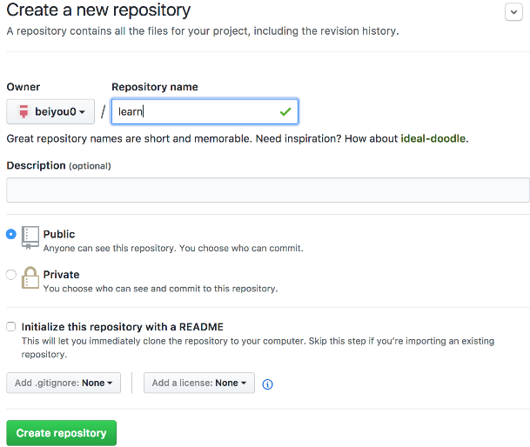

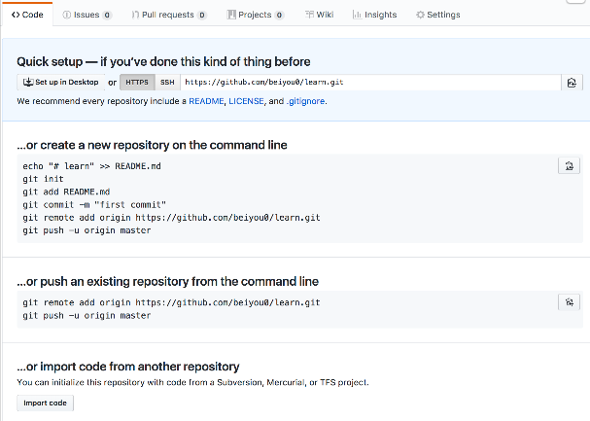

1. 本地工程目录下，创建远程代码仓库链接

git remote add origin [git@github.ibm.com:DSWESB/kafkaTesting.git](https://github.com/beiyou0/learn.git)

git remote -v // 查看remote git repository

git push -u origin master